SIMATS ENGINEERING (SAVEETHA SCHOOL OF ENGINEERING)
Course Code & Title: | ECA5604 -5G/6G COMMUNICATION | Course Faculty: | Dr.K.Sathish
Student Name: | Velamuri Bhanodhay | Reg. No.: | 192412330
Dept / Batch: | BE.ECE / 2024 | Date: | /7/2026
Lab Observation

Experiment 5 : MIMO System Simulation with BER Analysis Date

Objective 1: To evaluate the Bit Error Rate (BER) performance of a MIMO system under different
SNR conditions.

Matlab Code:

clc;clear
S=0:2:20; B=zeros(size(S));
for i=1:length(S)
b=randi([0 1],1e4,1); x=2*b-1;
H=(randn+1j*randn)/sqrt(2);
n=(randn(1,1e4)+1j*randn(1,1e4))/sqrt(2*10^(S(i)/10));
r=real(H*x'+n)>0;
B(i)=mean(r'~=b);
end
subplot(211)
semilogy(S,B,'-o')
grid on
title('MIMO BER Performance vs SNR')
xlabel('SNR (dB)'),ylabel('Bit Error Rate (BER)')
subplot(212)
plot(S,1-B,'-s')
grid on
title('MIMO System Reliability vs SNR')
xlabel('SNR (dB)'),ylabel('Reliability (1 - BER)')

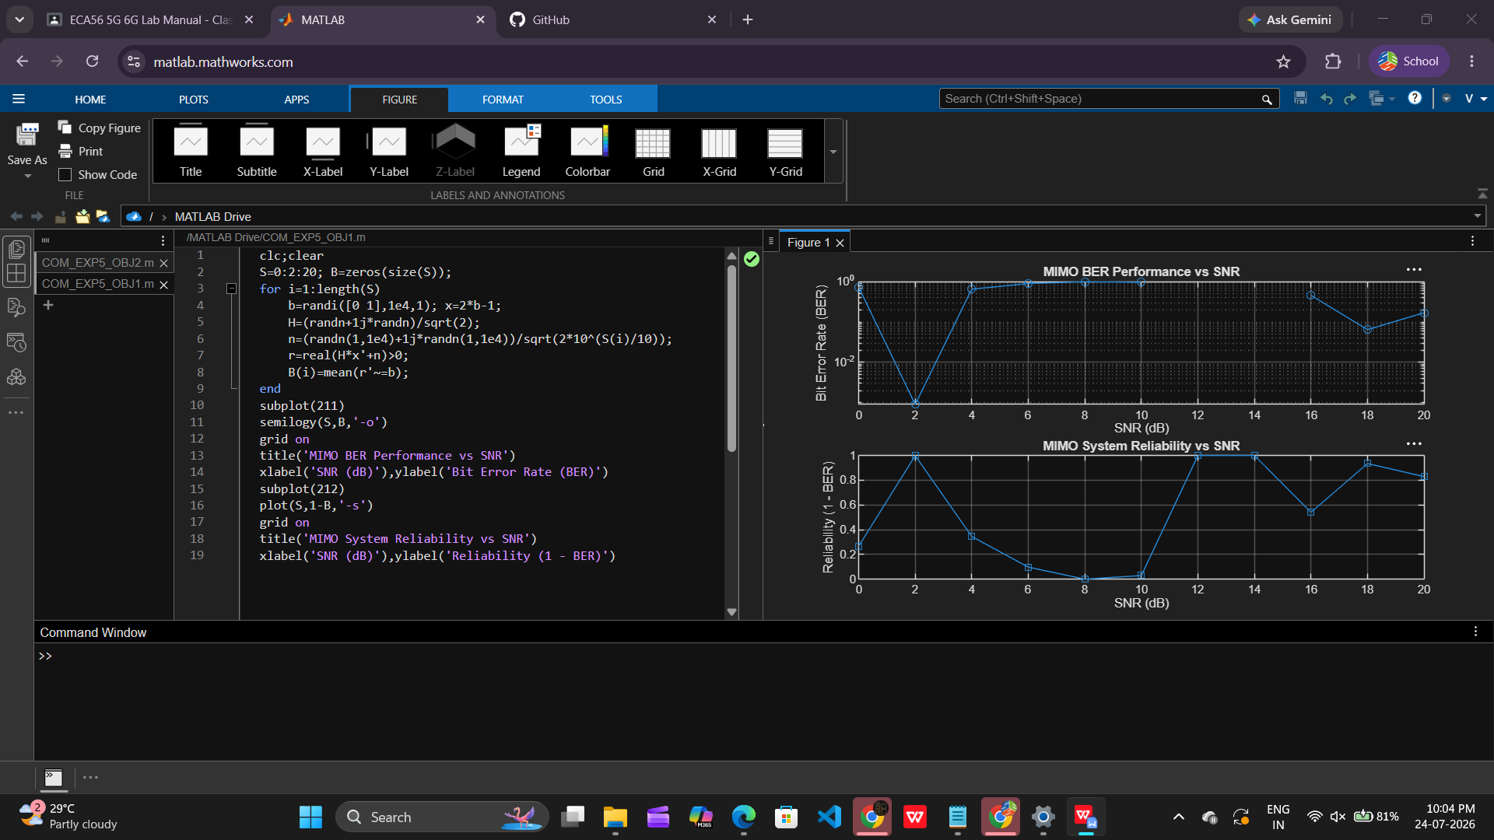

Objective 2: To analyze the impact of Signal-to-Noise Ratio (SNR in dB) on the reliability and
quality of MIMO communication.

Matlab Code:

clc;clear
S=0:2:20; R=zeros(size(S));
for i=1:length(S)
N=1/10^(S(i)/10);
R(i)=1-exp(-10^(S(i)/10)/10);
end
subplot(211)
plot(S,R,'-o')
grid on
title('MIMO Reliability vs SNR')
xlabel('SNR (dB)'),ylabel('Reliability (0 to 1)')
subplot(212)
plot(S,N*ones(size(S)),'-s')
grid on
title('Noise Power Variation with SNR')
xlabel('SNR (dB)'),ylabel('Noise Power')

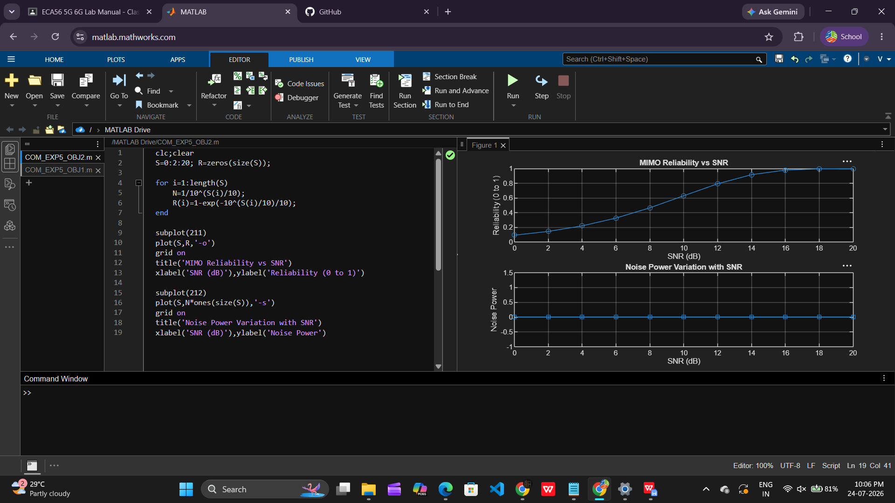

Objective 3: To compute the Channel Capacity (bps/Hz) and study how MIMO improves spectral
efficiency compared to single antenna systems.

Matlab Code:

clc;clear
R=[10 12 8 15 5]; M=[2 4 6 4 2]; U=1:5;
T=R.*180e3.*M/1e6;

disp('User Throughput (Mbps):')
disp(T')

subplot(211)
plot(U,T,'-o')
grid on
title('OFDMA User Throughput')
xlabel('User Index'),ylabel('Throughput (Mbps)')

subplot(212)
plot(R,T,'-s')
grid on
title('Resource Blocks vs Throughput')
xlabel('Allocated Resource Blocks')
ylabel('Throughput (Mbps)')

